

**B.M.S**

**COLLEGE**

**OF**

**ENGINEERING**

**BENGALURU**

Autonomous

Institute,

Affiliated

to

VTU

OOMD

Lab

Report

**Software**

**Engineering**

**and**

**Object-Oriented**

**Modelling**

Submitted

in

partial

fulfillment

for

the

award

of

degree

of

Bachelor

of

Engineering

in

Computer

Science

and

Engineering

Submitted

by:

**Archit**

**Mehrotra**

**(1**

**BM21CS**

**031)**

Department

of

Computer

Science

and

Engineering

B.M.S

College

of

Engineering

Bull

Temple

Road,

Basavanagudi,

Bangalore

560

019

2023-2024



**BMS**

**COLLEGE**

**OF**

**ENGINEERING**

**DEPARTMENT**

**OF**

**COMPUTER**

**SCIENCE**

**AND**

**ENGINEERING**

**CERTIFICATE**

This

is

to

certify

that

the

Software

Engineering

and

Object-Oriented

Modelling

Lab

report

has

been

carried

out

by

Archit

Mehrotra

031)

(1

BM21CS

during

the

academic

year

2023-2024.

Signature

of

the

Faculty

in

Charge

Signature

of

the

HOD

**SYED**

**AKRAM**

**DR.**

**JYOTHI**

**S**

**NAYAK**

Assistant

Professor

Professor

and

Head

CSE,

BMSCE

CSE,

BMSCE



**Table**

**of**

**Contents**

**SI.**

**No.**

**Title**

**Page**

**No.**

1

Hotel

Management

System

1-7

2

Credit

Card

Processing

8-13

3

Library

Management

System

14-20

4

Stock

Maintenance

System

21-26

5

Passport

Automation

System

27-33

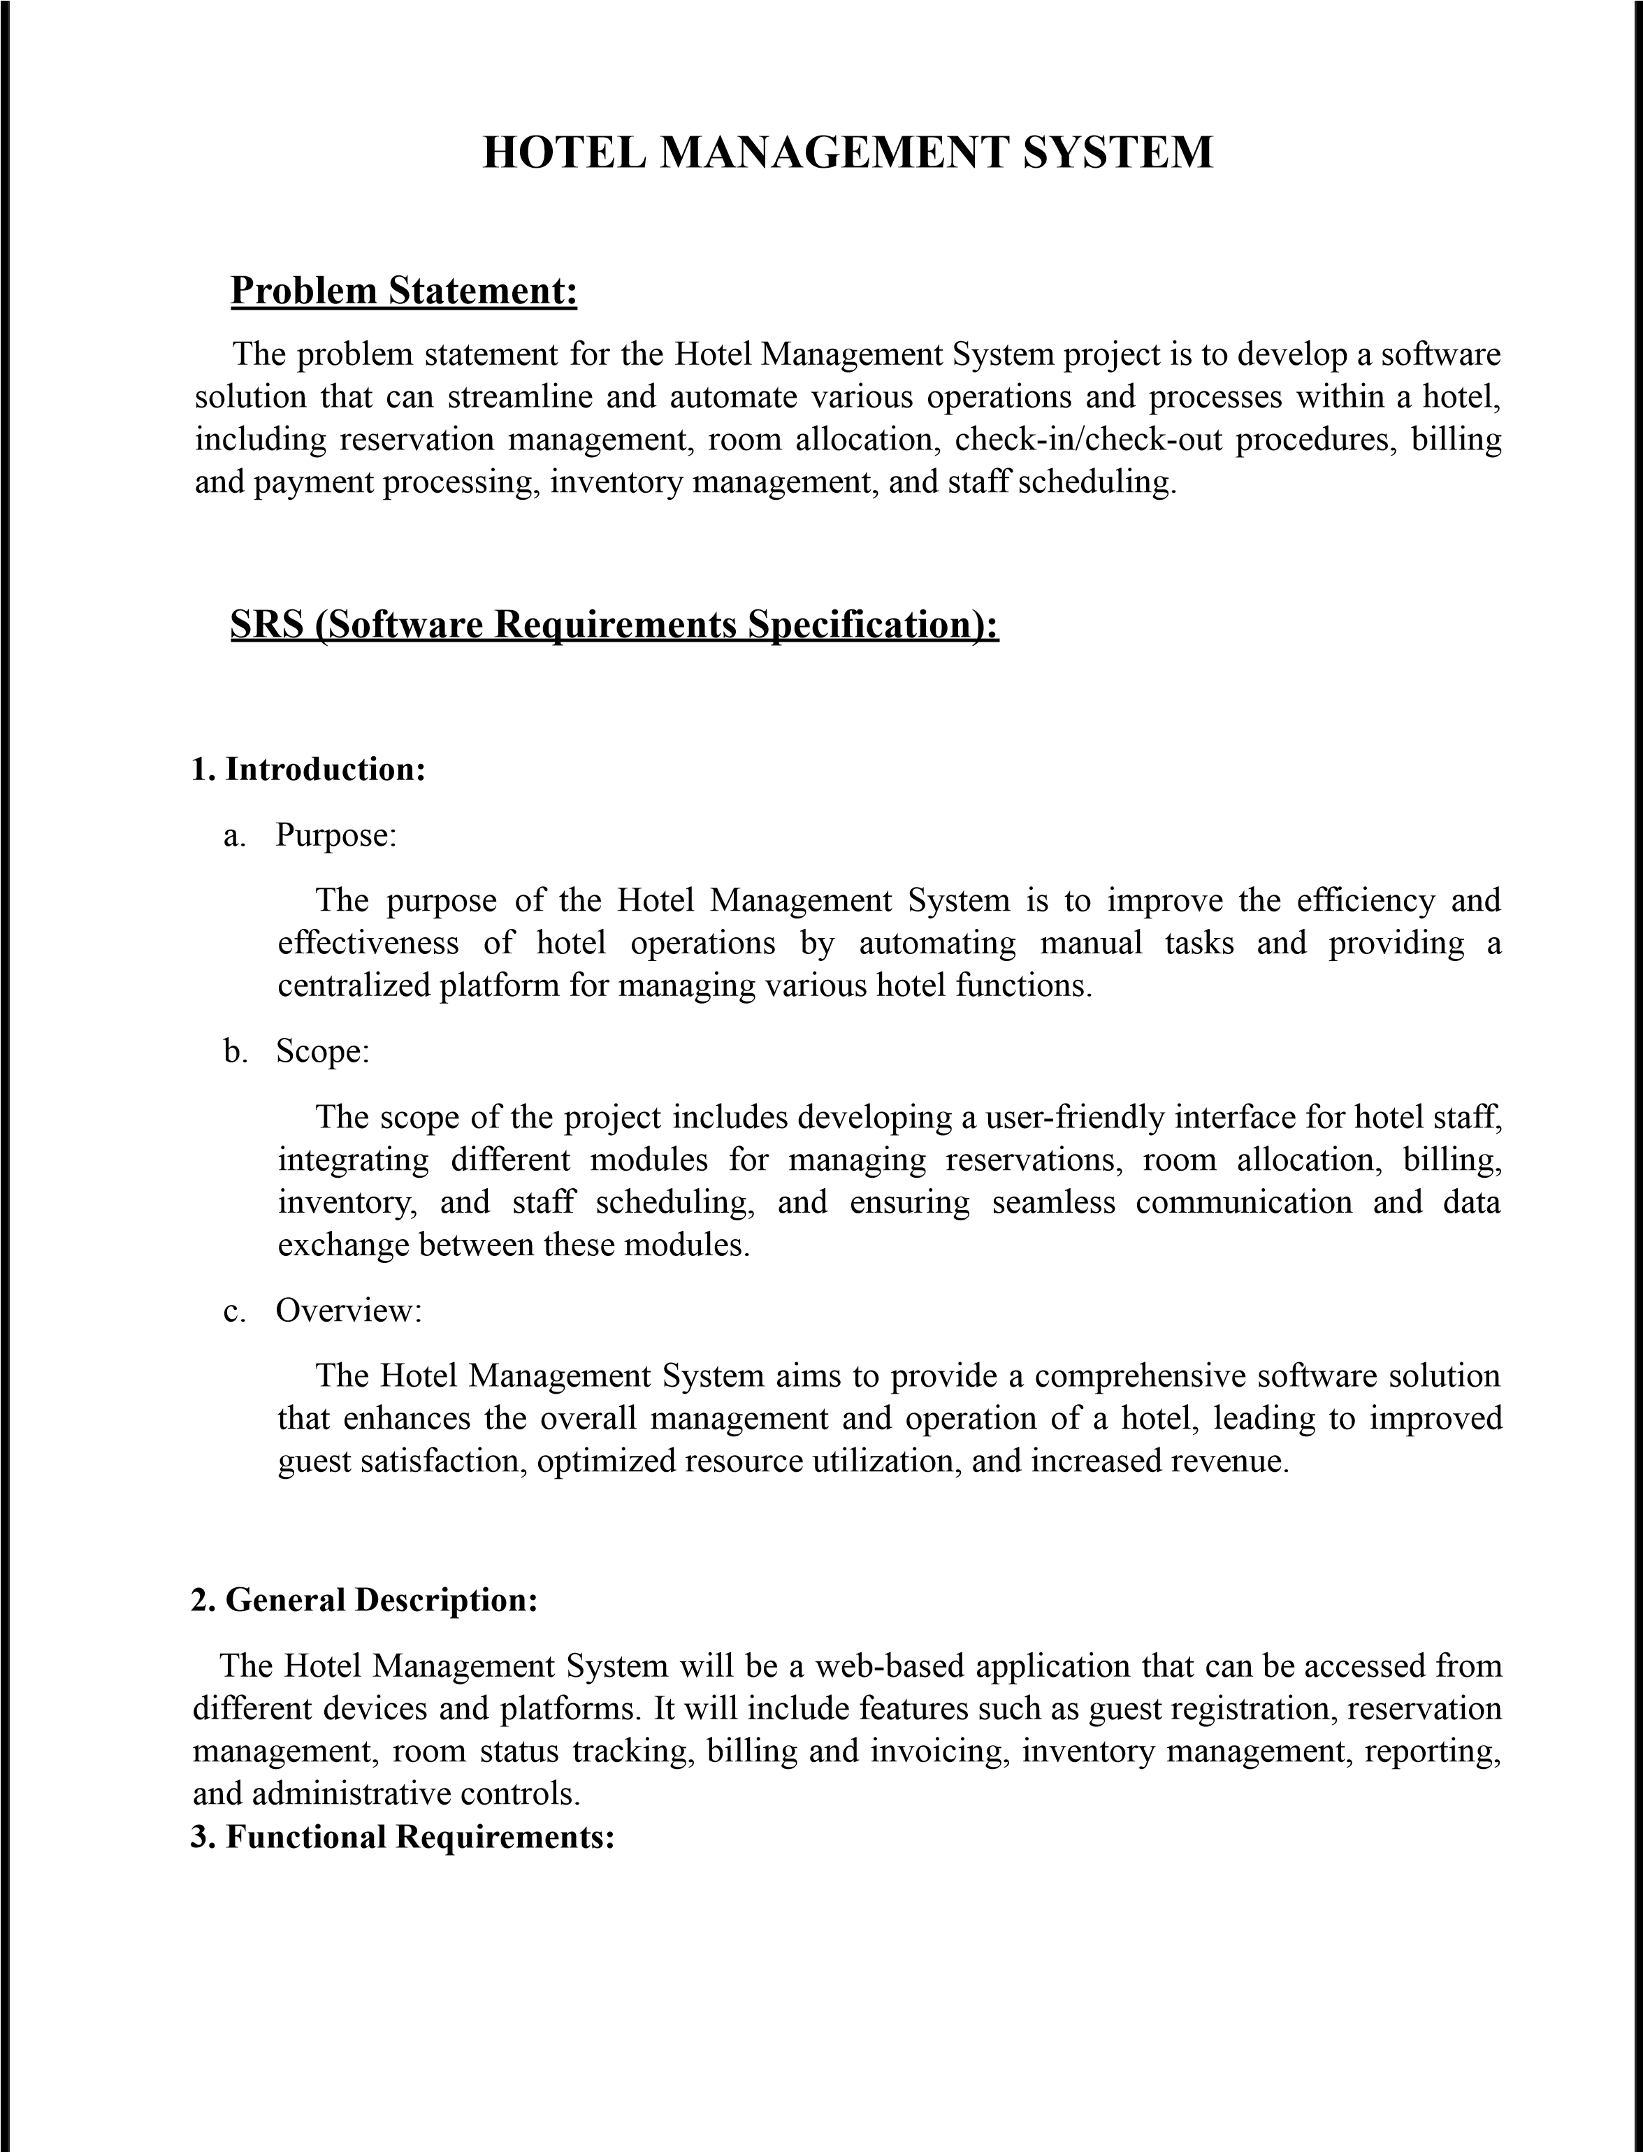



•

User

registration

and

login

functionality

•

Guest

registration

and

check-in/check-out

process

•

Reservation

management,

including

room

availability

and

booking

•

Room

allocation

and

assignment

•

Billing

and

payment

processing

•

Inventory

management

for

tracking

and

managing

hotel

supplies

•

Staff

scheduling

and

management

•

Reporting

and

analytics

for

monitoring

hotel

performance

**4.**

**Interface**

**Requirements:**

•

Intuitive

and

user-friendly

interface

for

hotel

staff

•

Responsive

design

to

support

different

devices

and

screen

sizes

•

Integration

with

external

systems

(

if

required)

such

as

payment

gateways

or

property

management

systems

**5.**

**Performance**

**Requirements:**

•

Fast

and

responsive

system

performance

to

ensure

quick

operations

•

Scalability

to

handle

a

large

number

of

concurrent

users

and

data

transactions

•

Reliable

data

storage

and

retrieval

to

prevent

data

loss

or

corruption

**6.**

**Design**

**Constraints:**

▪

Compliance

with

security

standards

and

regulations

to

protect

sensitive

guest

information

▪

Integration

with

existing

hotel

systems

or

technologies

(

if

applicable)

▪

Compatibility

with

popular

web

browsers

and

operating

systems

**7.**

**Non-Functional**

**Attributes:**

•

Usability:

The

system

should

be

intuitive

and

easy

to

navigate

for

hotel

staff.

•

Reliability:

The

system

should

be

reliable

and

available

24

/

7

to

handle

hotel

operations

without

interruptions.



•

Security:

The

system

should

ensure

the

confidentiality

and

integrity

of

guest

and

hotel

data.

•

Performance:

The

system

should

deliver

fast

response

times

and

handle

concurrent

user

requests

efficiently.

•

Maintainability:

The

system

should

be

easy

to

maintain

and

update

with

minimal

downtime.



Figure

1.1

Class

Diagram

of

Hotel

Management

System

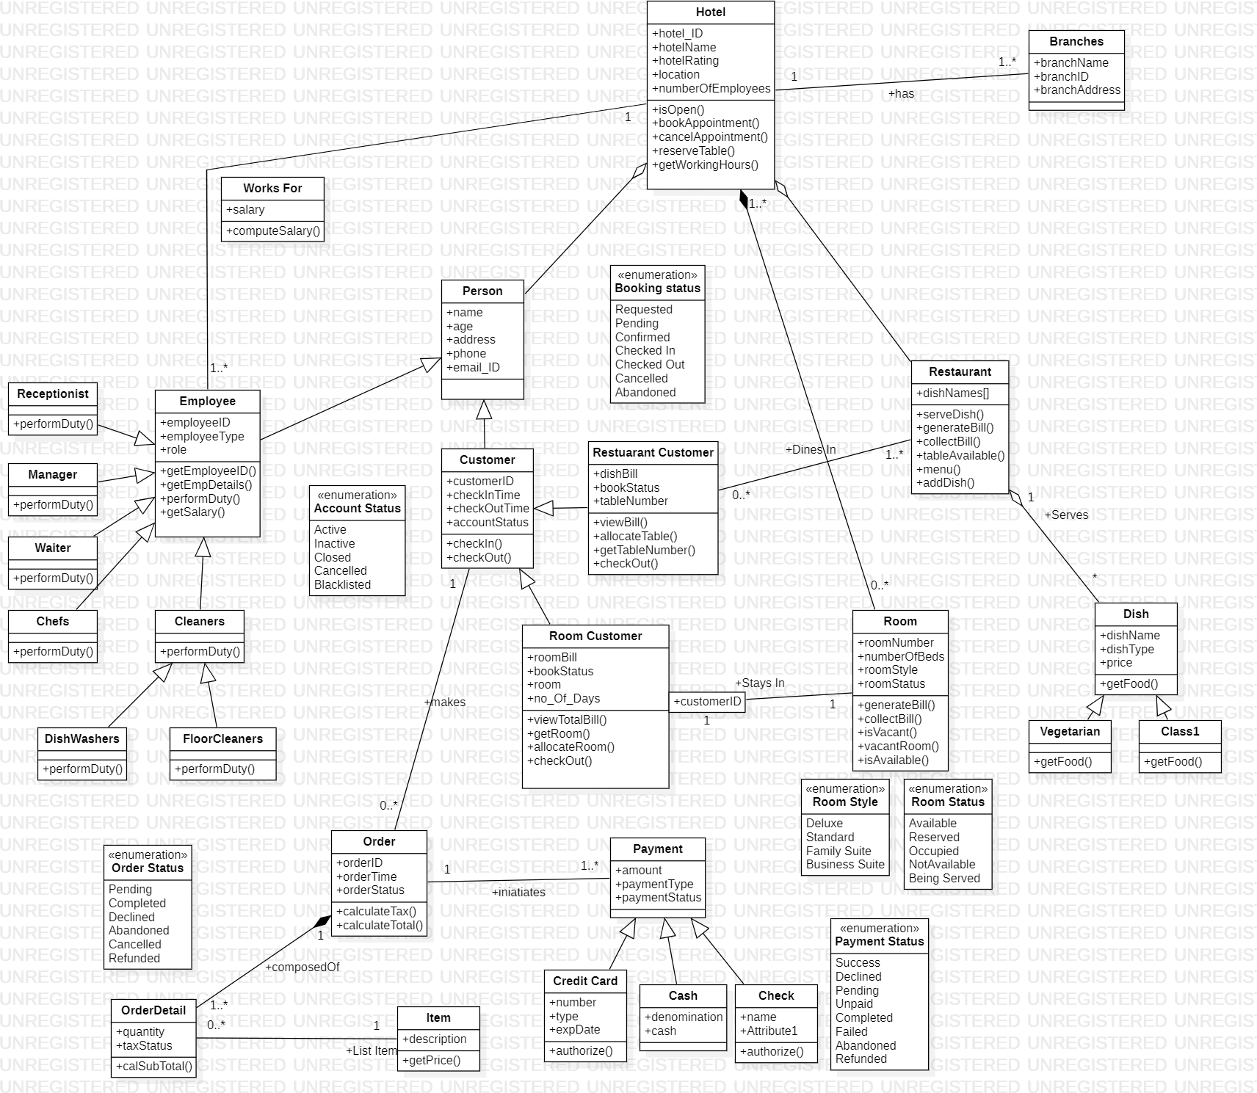

Figure

1.1

State

Diagram

of

Hotel

Management

System

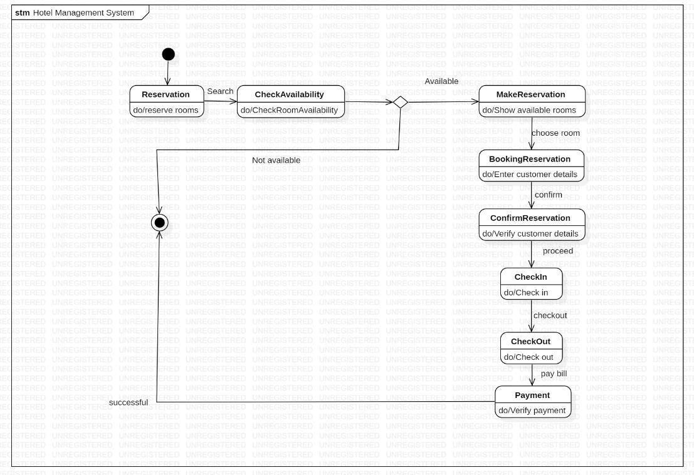

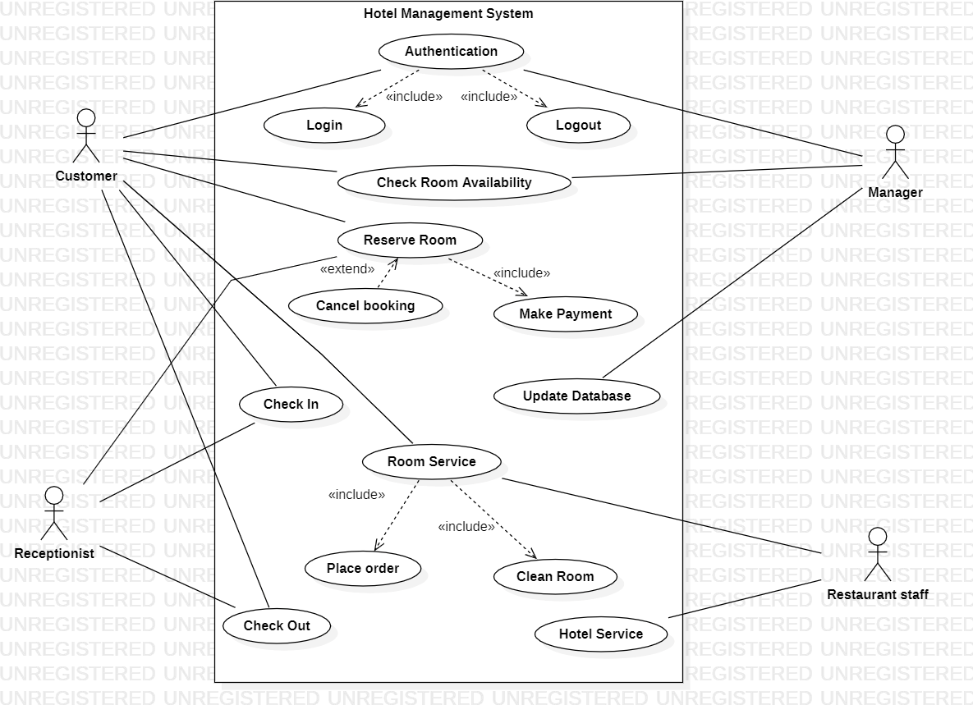

Figure 1.3 Use case Diagram of Hotel Management System

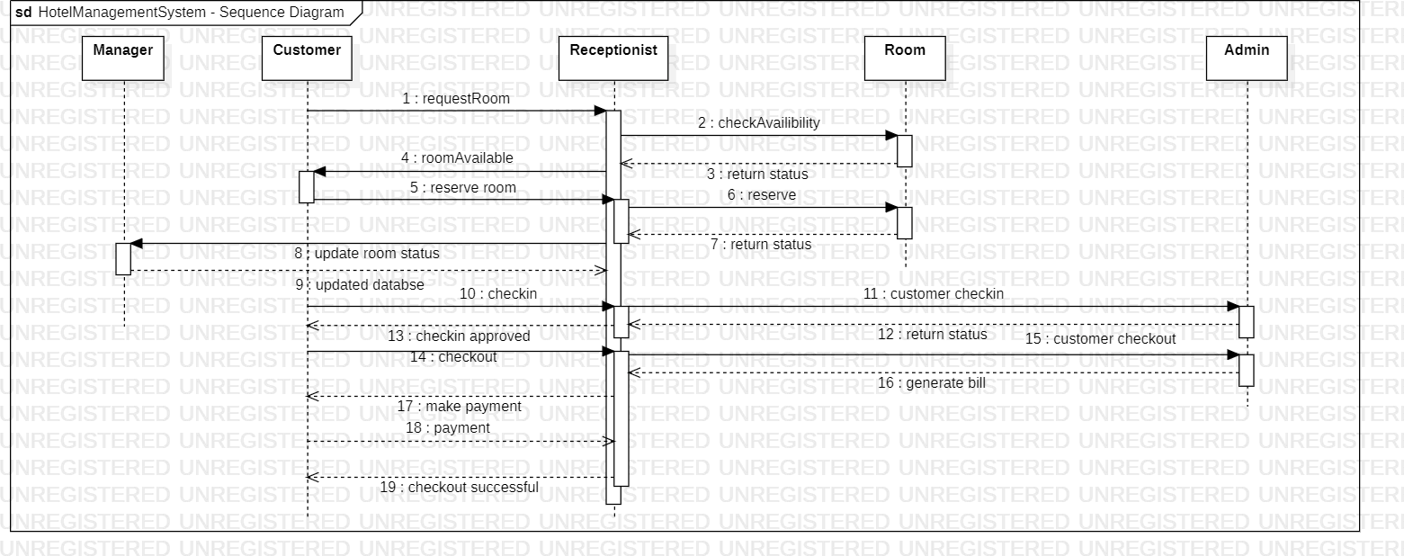

Figure 1.4 Sequence Diagram of Hotel Management System

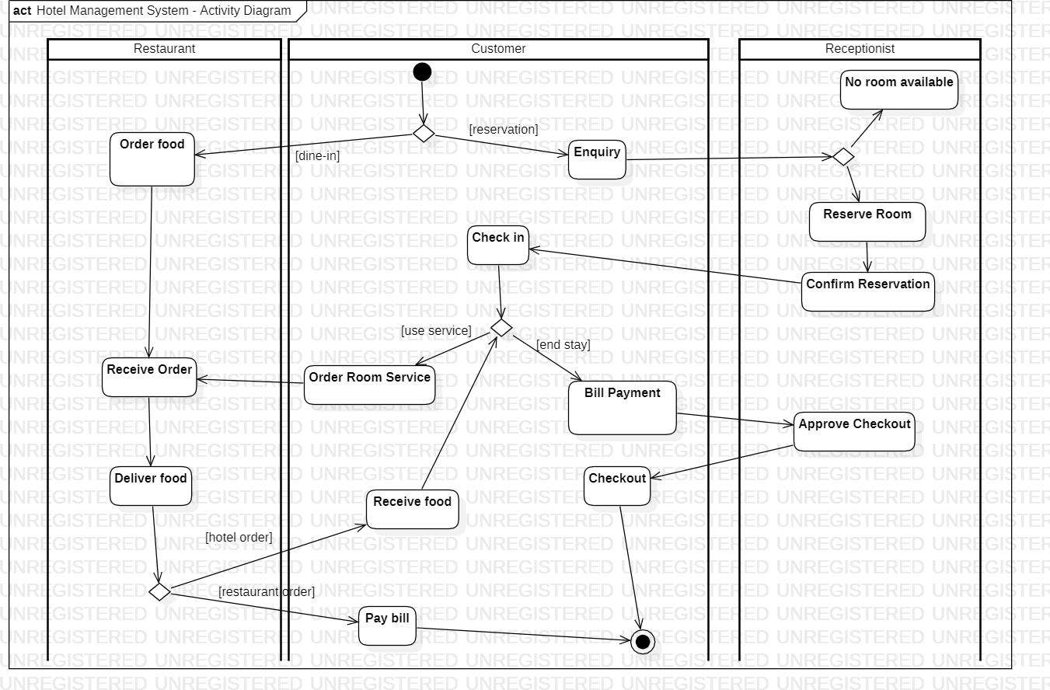

Figure 1.5 Activity Diagram of Hotel Management System

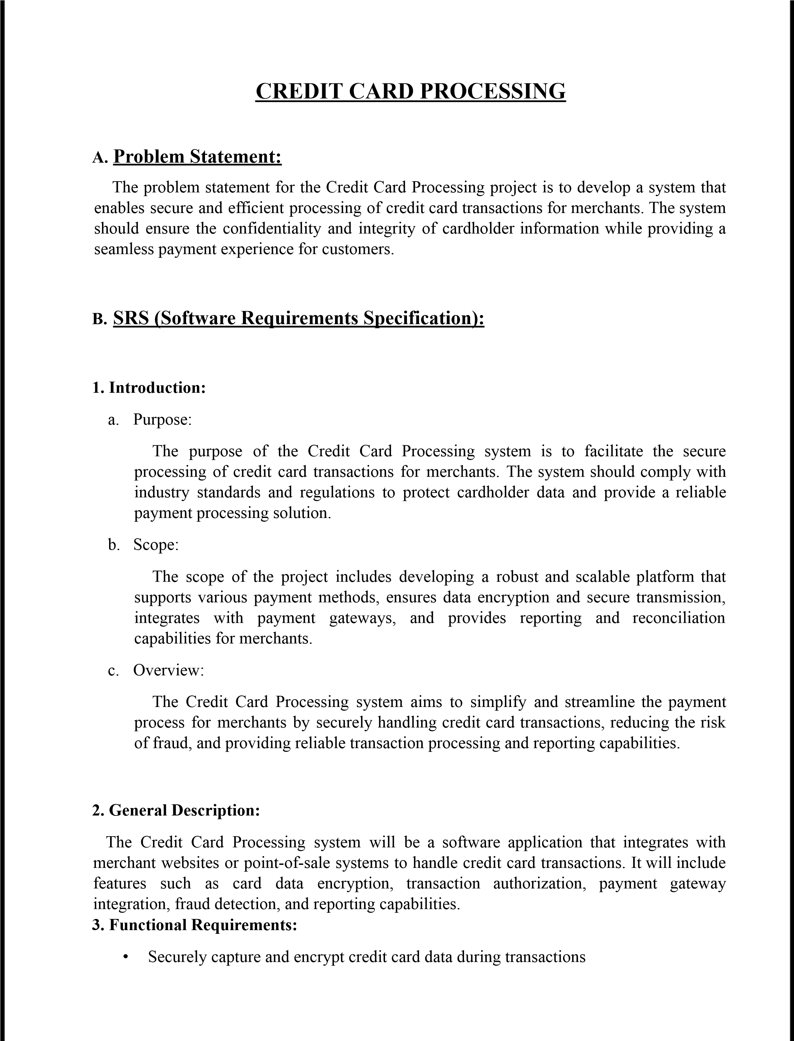

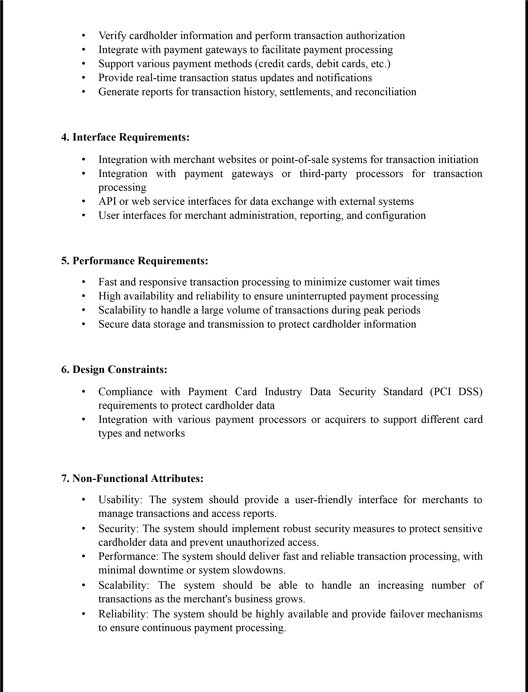



Figure

2.1

Class

Diagram

of

Credit

Card

Processing

System

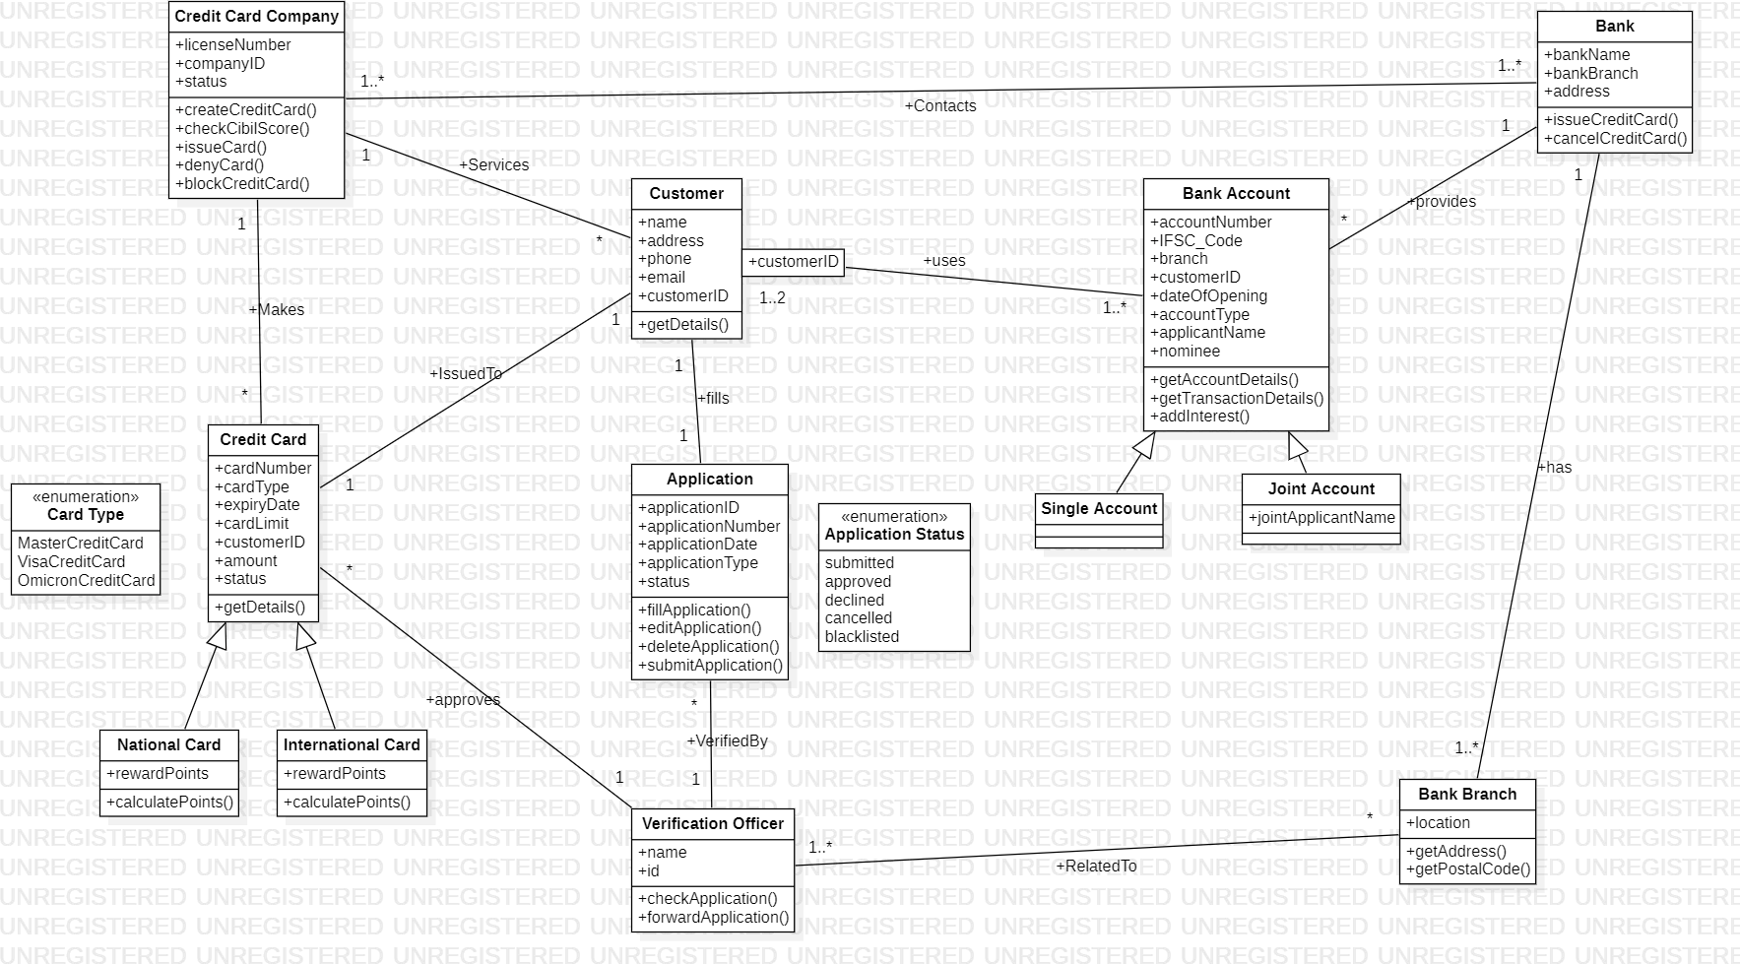

Figure

2.2

State

Diagram

of

Credit

Card

Processing

System

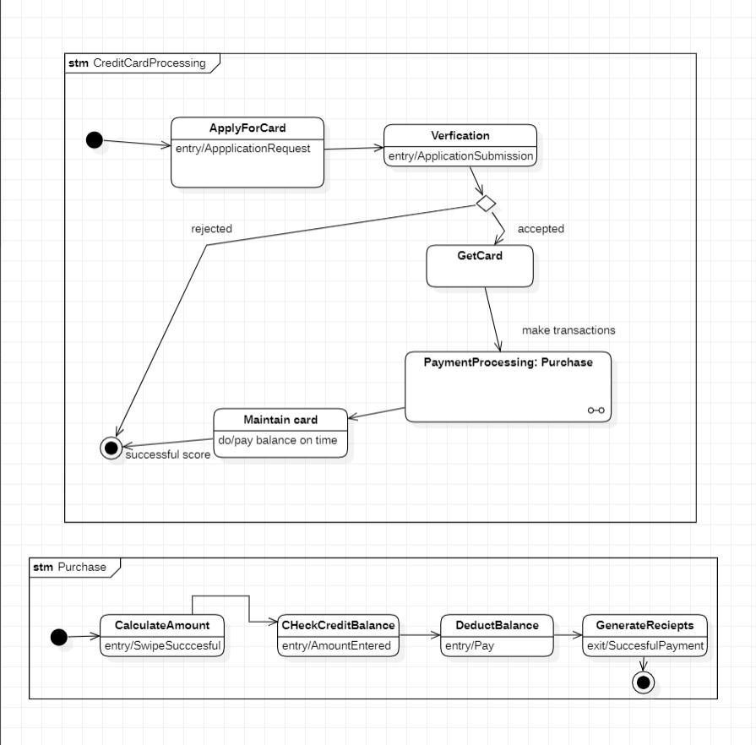

Figure

2.2

Usecase

Diagram

of

Credit

Card

Processing

System

Figure

2.4

Sequence

Diagram

of

Credit

Card

Processing

System

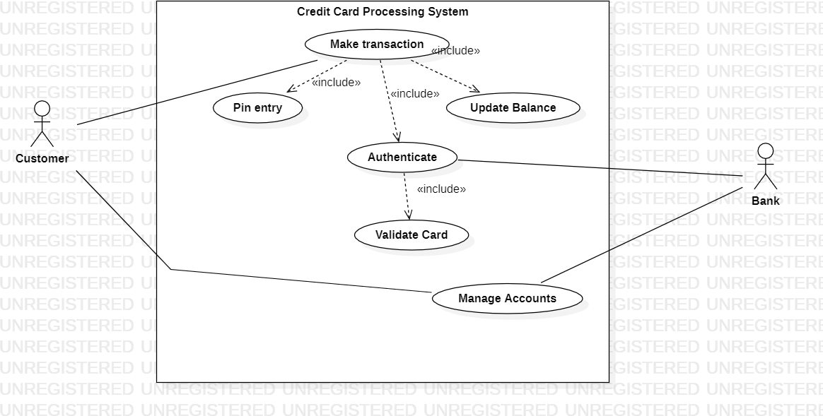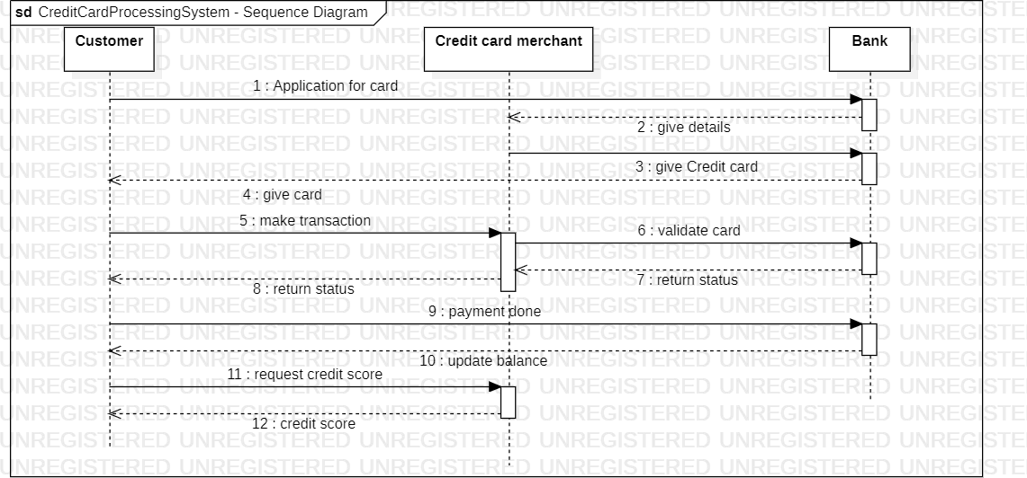

Figure

2.5

Activity

Diagram

of

Credit

Card

Processing

System

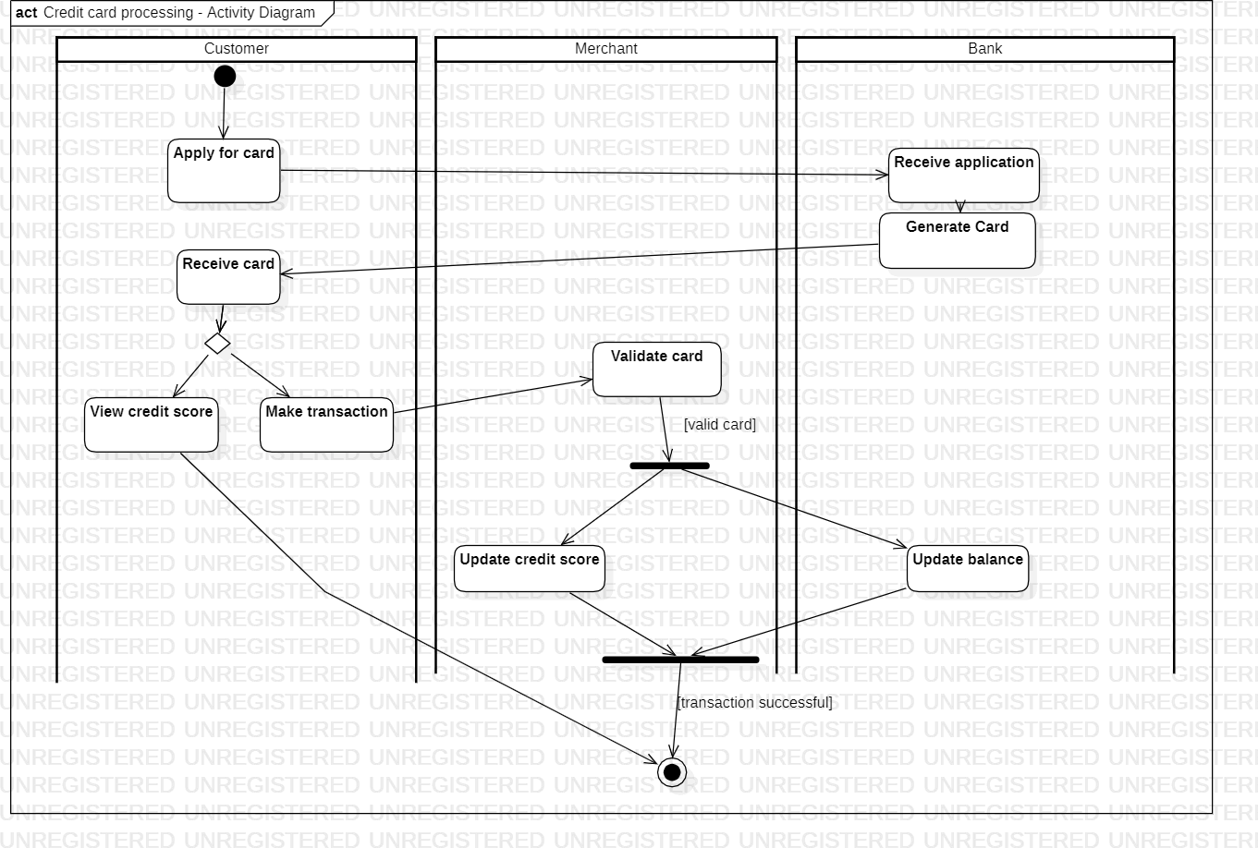

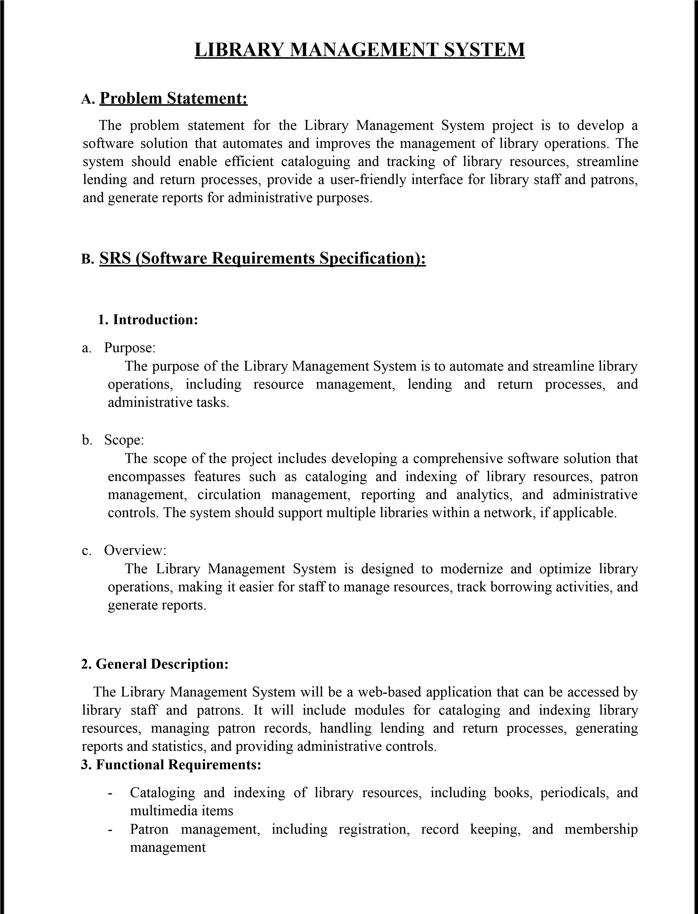

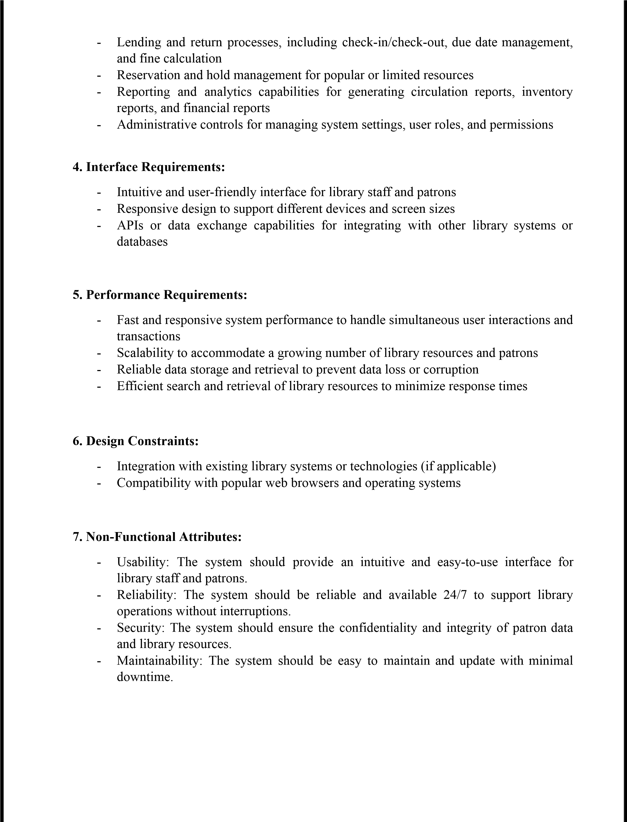



Figure

3.1

Class

Diagram

of

Library

Management

System

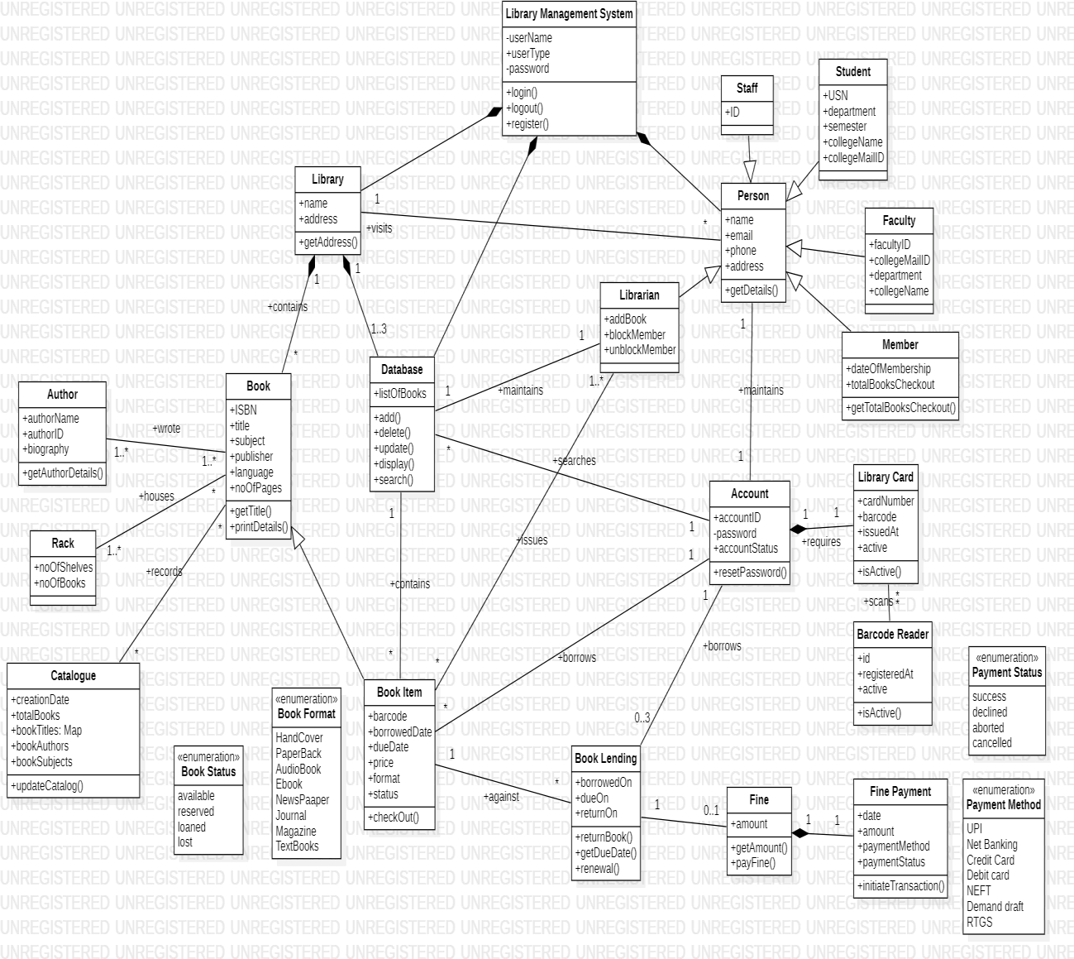

Figure

3.2

State

Diagram

of

Library

Management

System

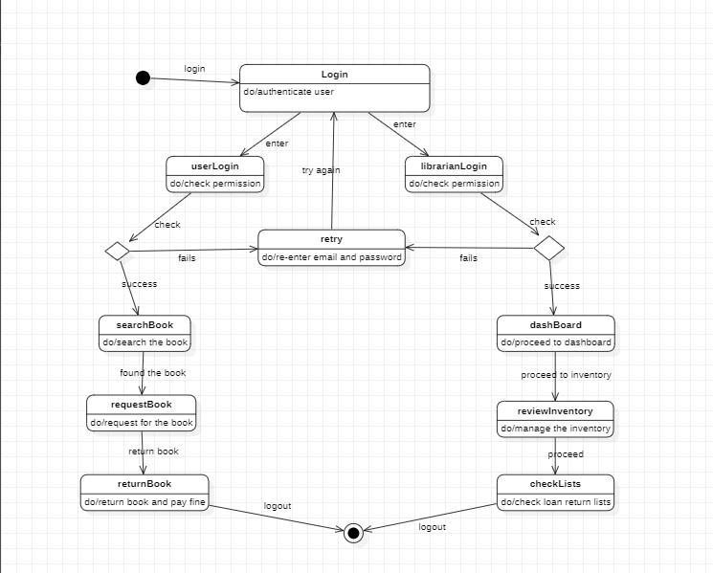

Figure

3.3

Usecase

Diagram

of

Library

Management

System

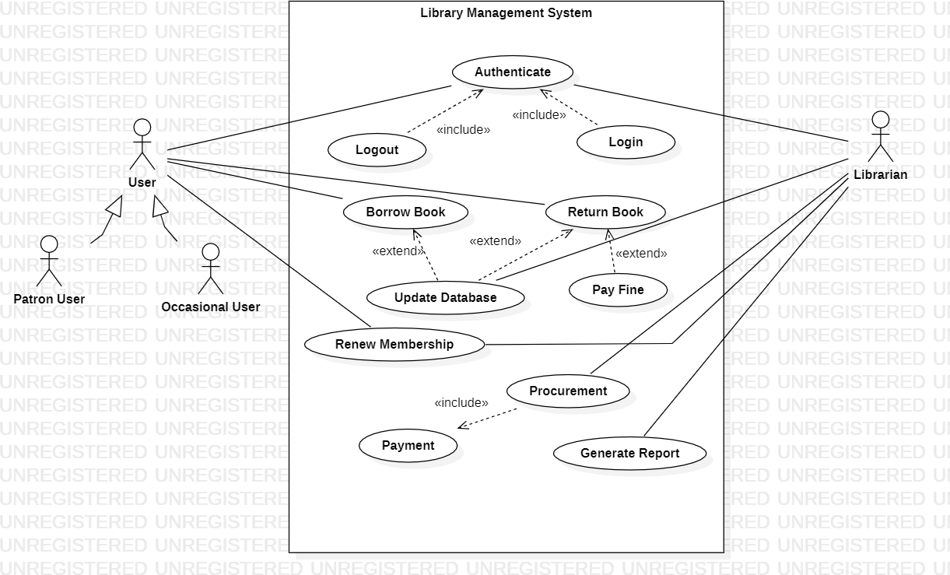

Figure

3.4

Sequence

Diagram

of

Library

Management

System

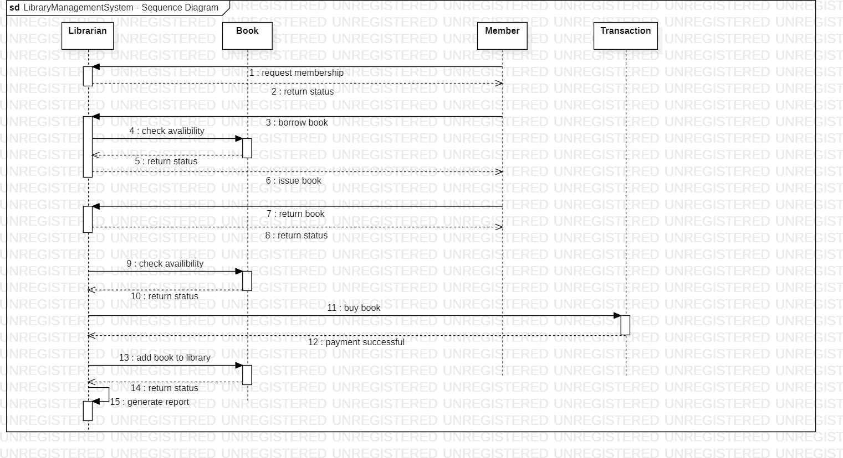

Figure

3.5

Activity

Diagram

of

Library

Management

System

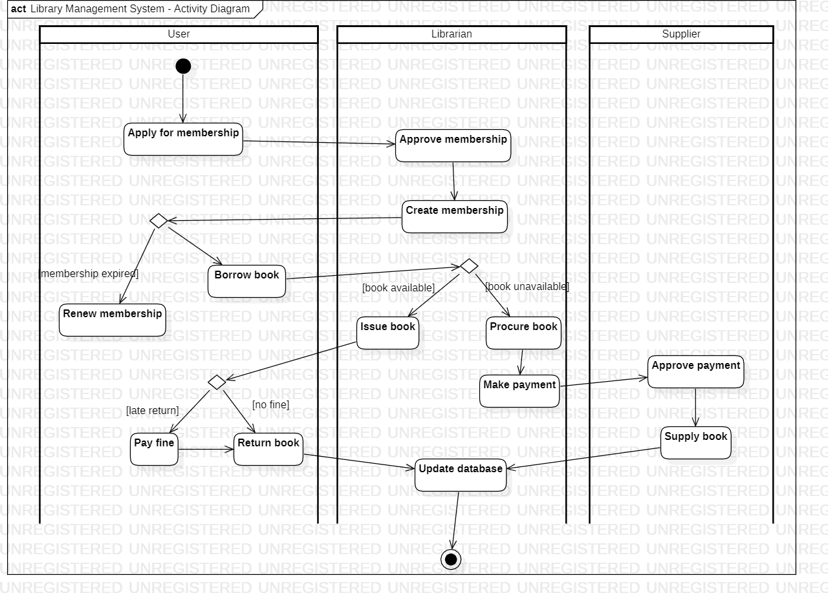

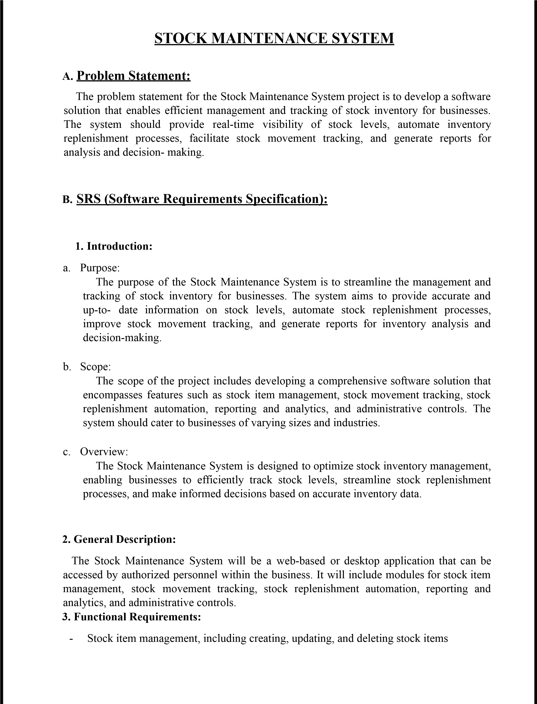

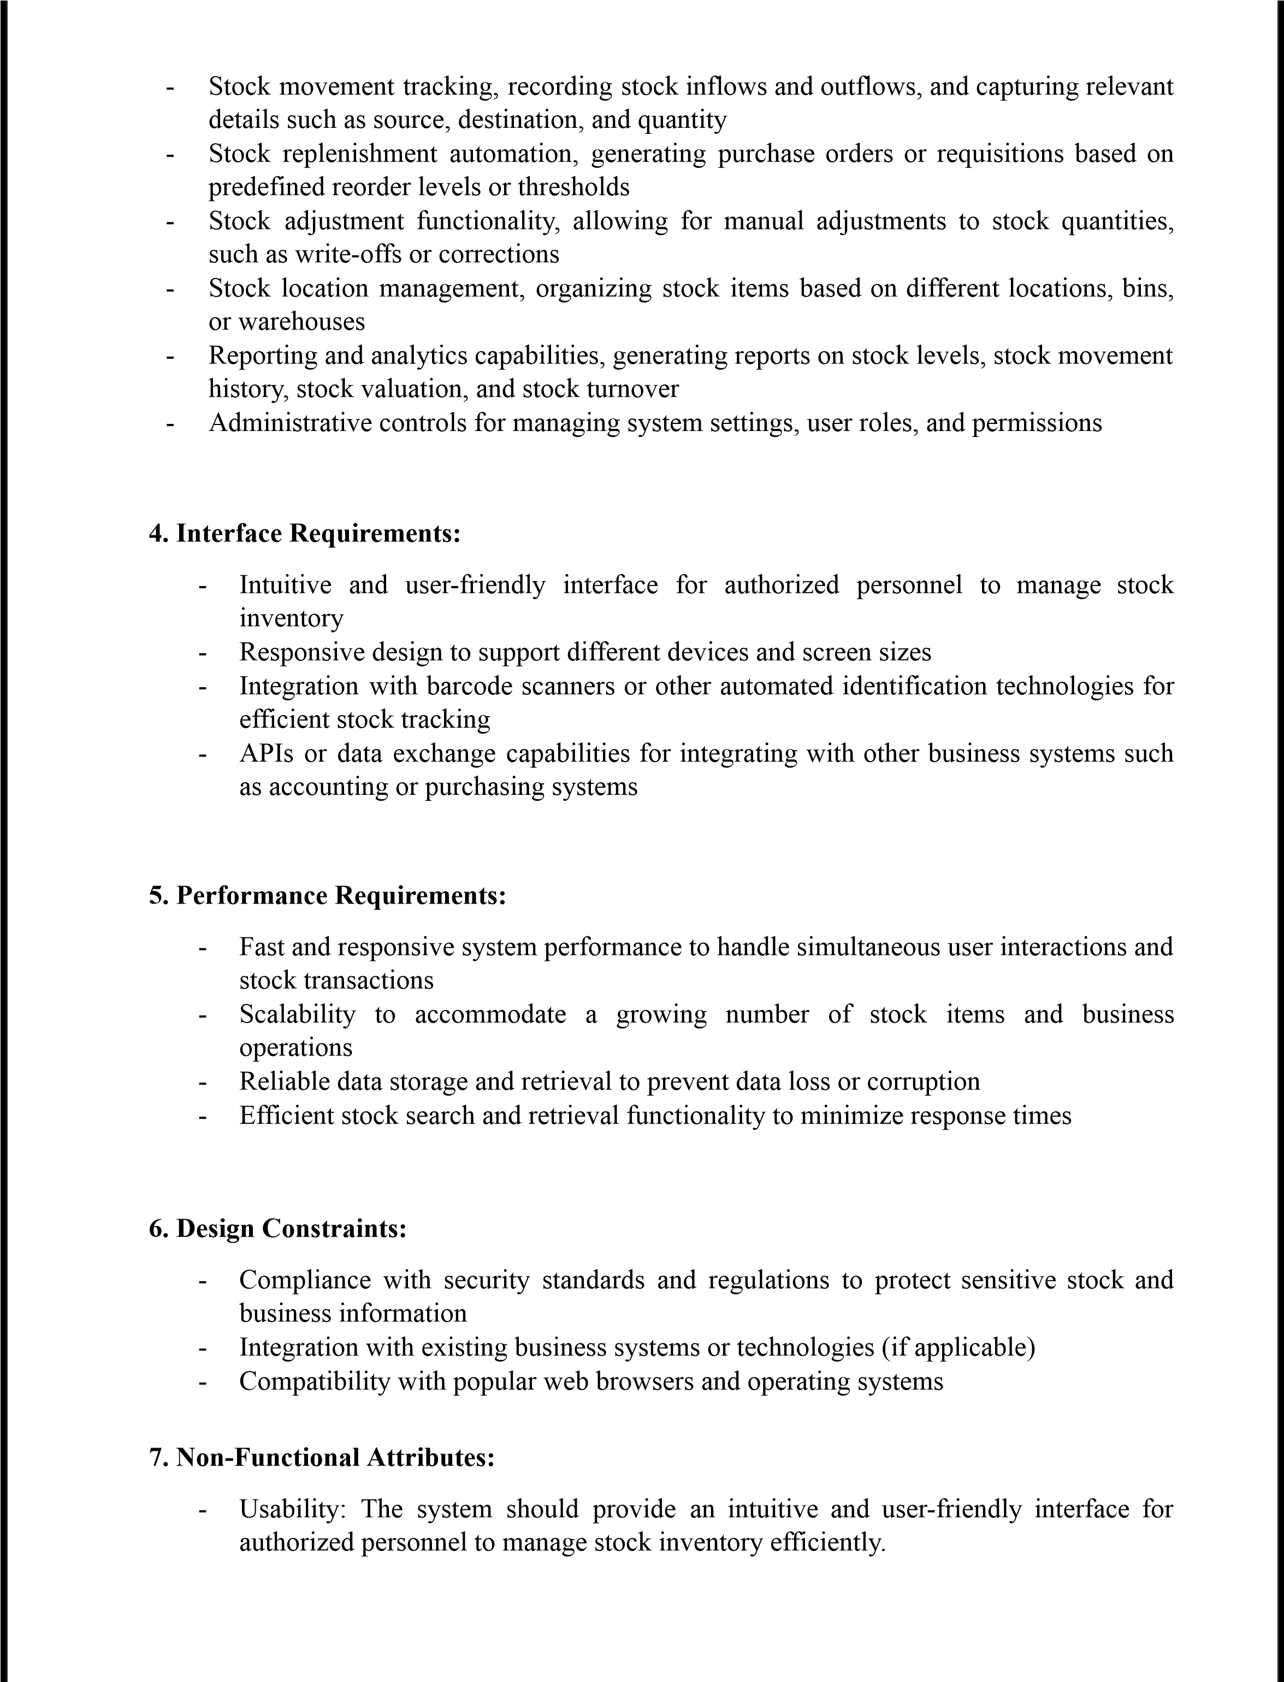



-

Reliability:

The

system

should

be

reliable

and

available

24

/

7

to

support

business

operations

without

interruptions.

-

Security:

The

system

should

ensure

the

confidentiality

and

integrity

of

stock

and

business

data.

-

Performance:

The

system

should

deliver

fast

response

times

and

handle

concurrent

user

requests

efficiently.

-

Maintainability:

The

system

should

be

easy

to

maintain

and

update

with

minimal

downtime.

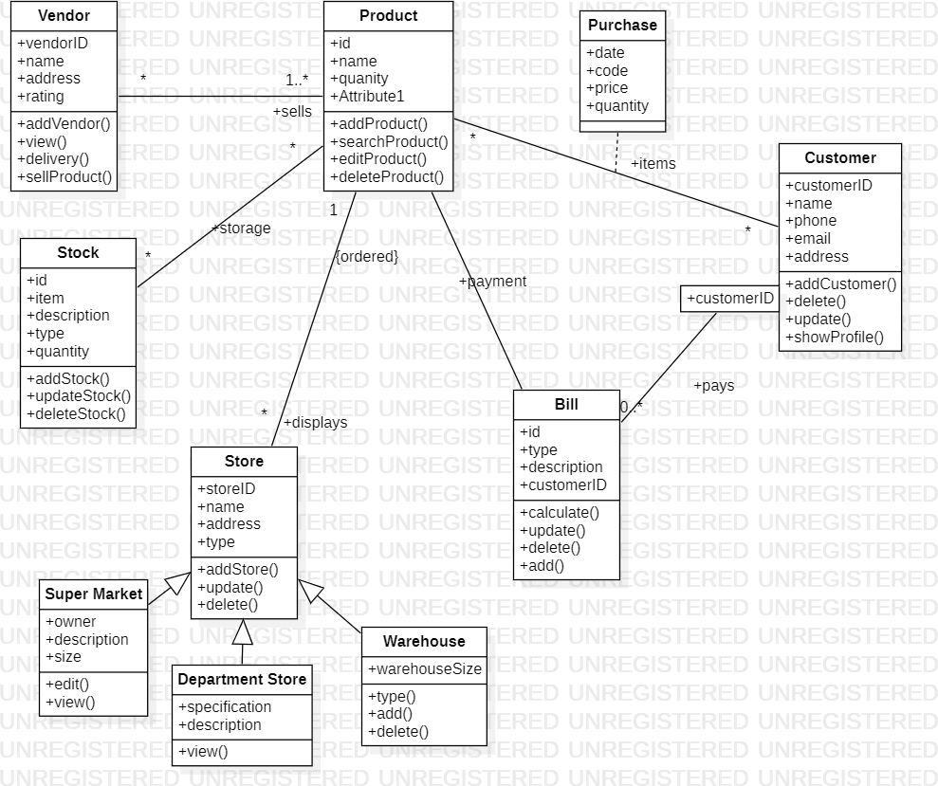

Figure

4.1

Class

Diagram

of

Stock

Maintenance

System

Figure

4.2

State

Diagram

of

Stock

Maintainance

System

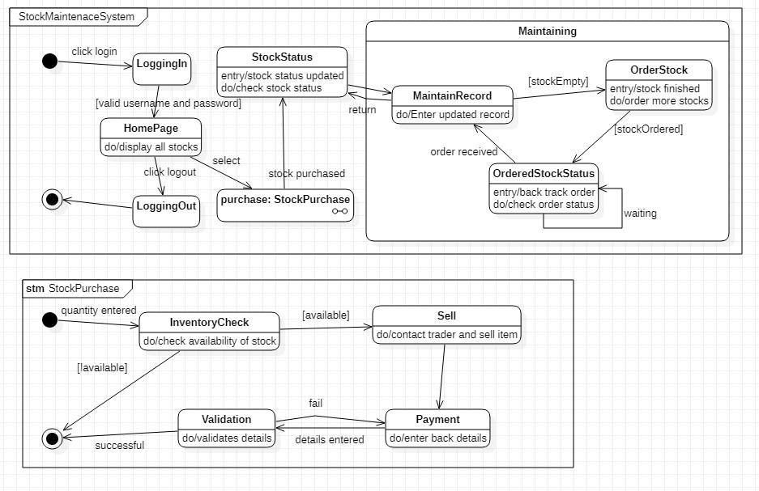

Figure

4.3

Usecase

Diagram

of

Stock

Maintainance

System

Figure

4.4

Sequence

Diagram

of

Stock

Maintenance

System

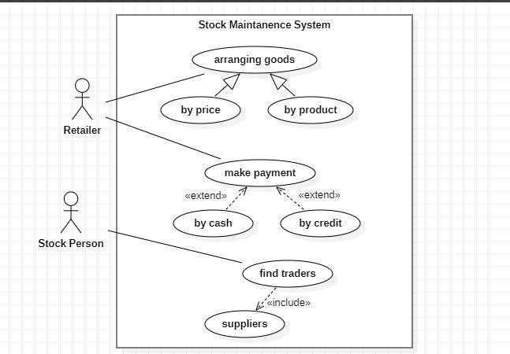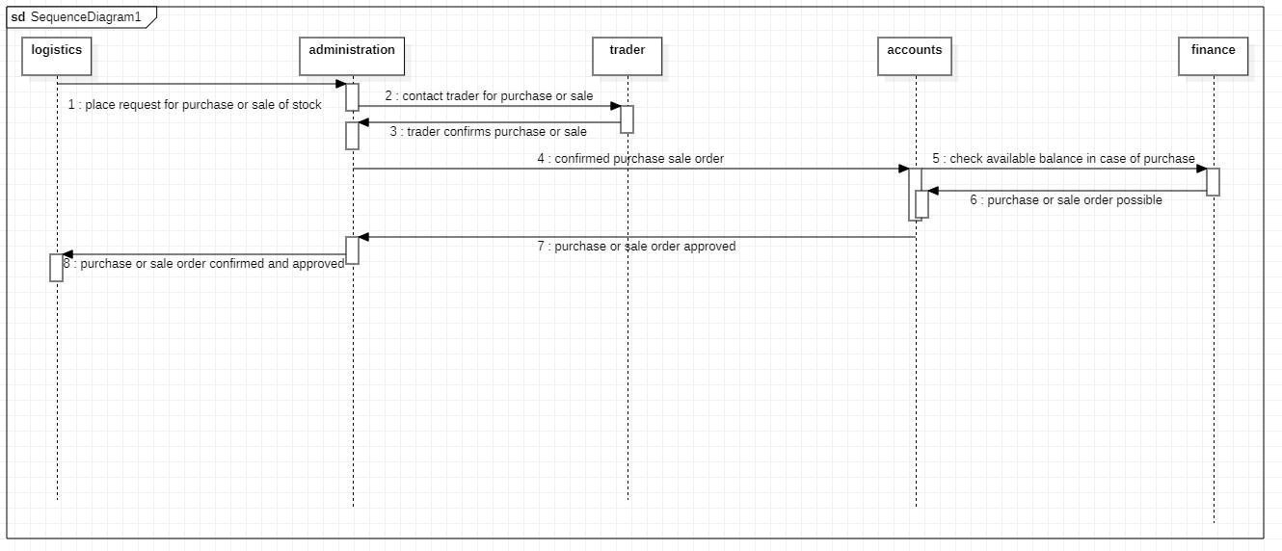

Figure

4.5

Activity

Diagram

of

Stock

Maintenance

System

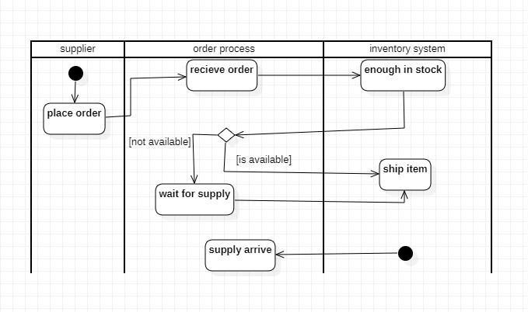

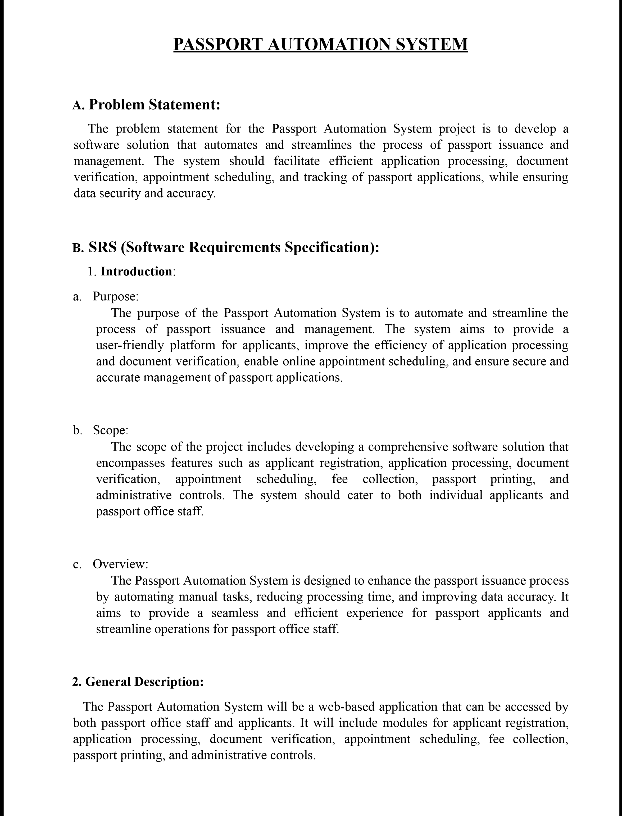

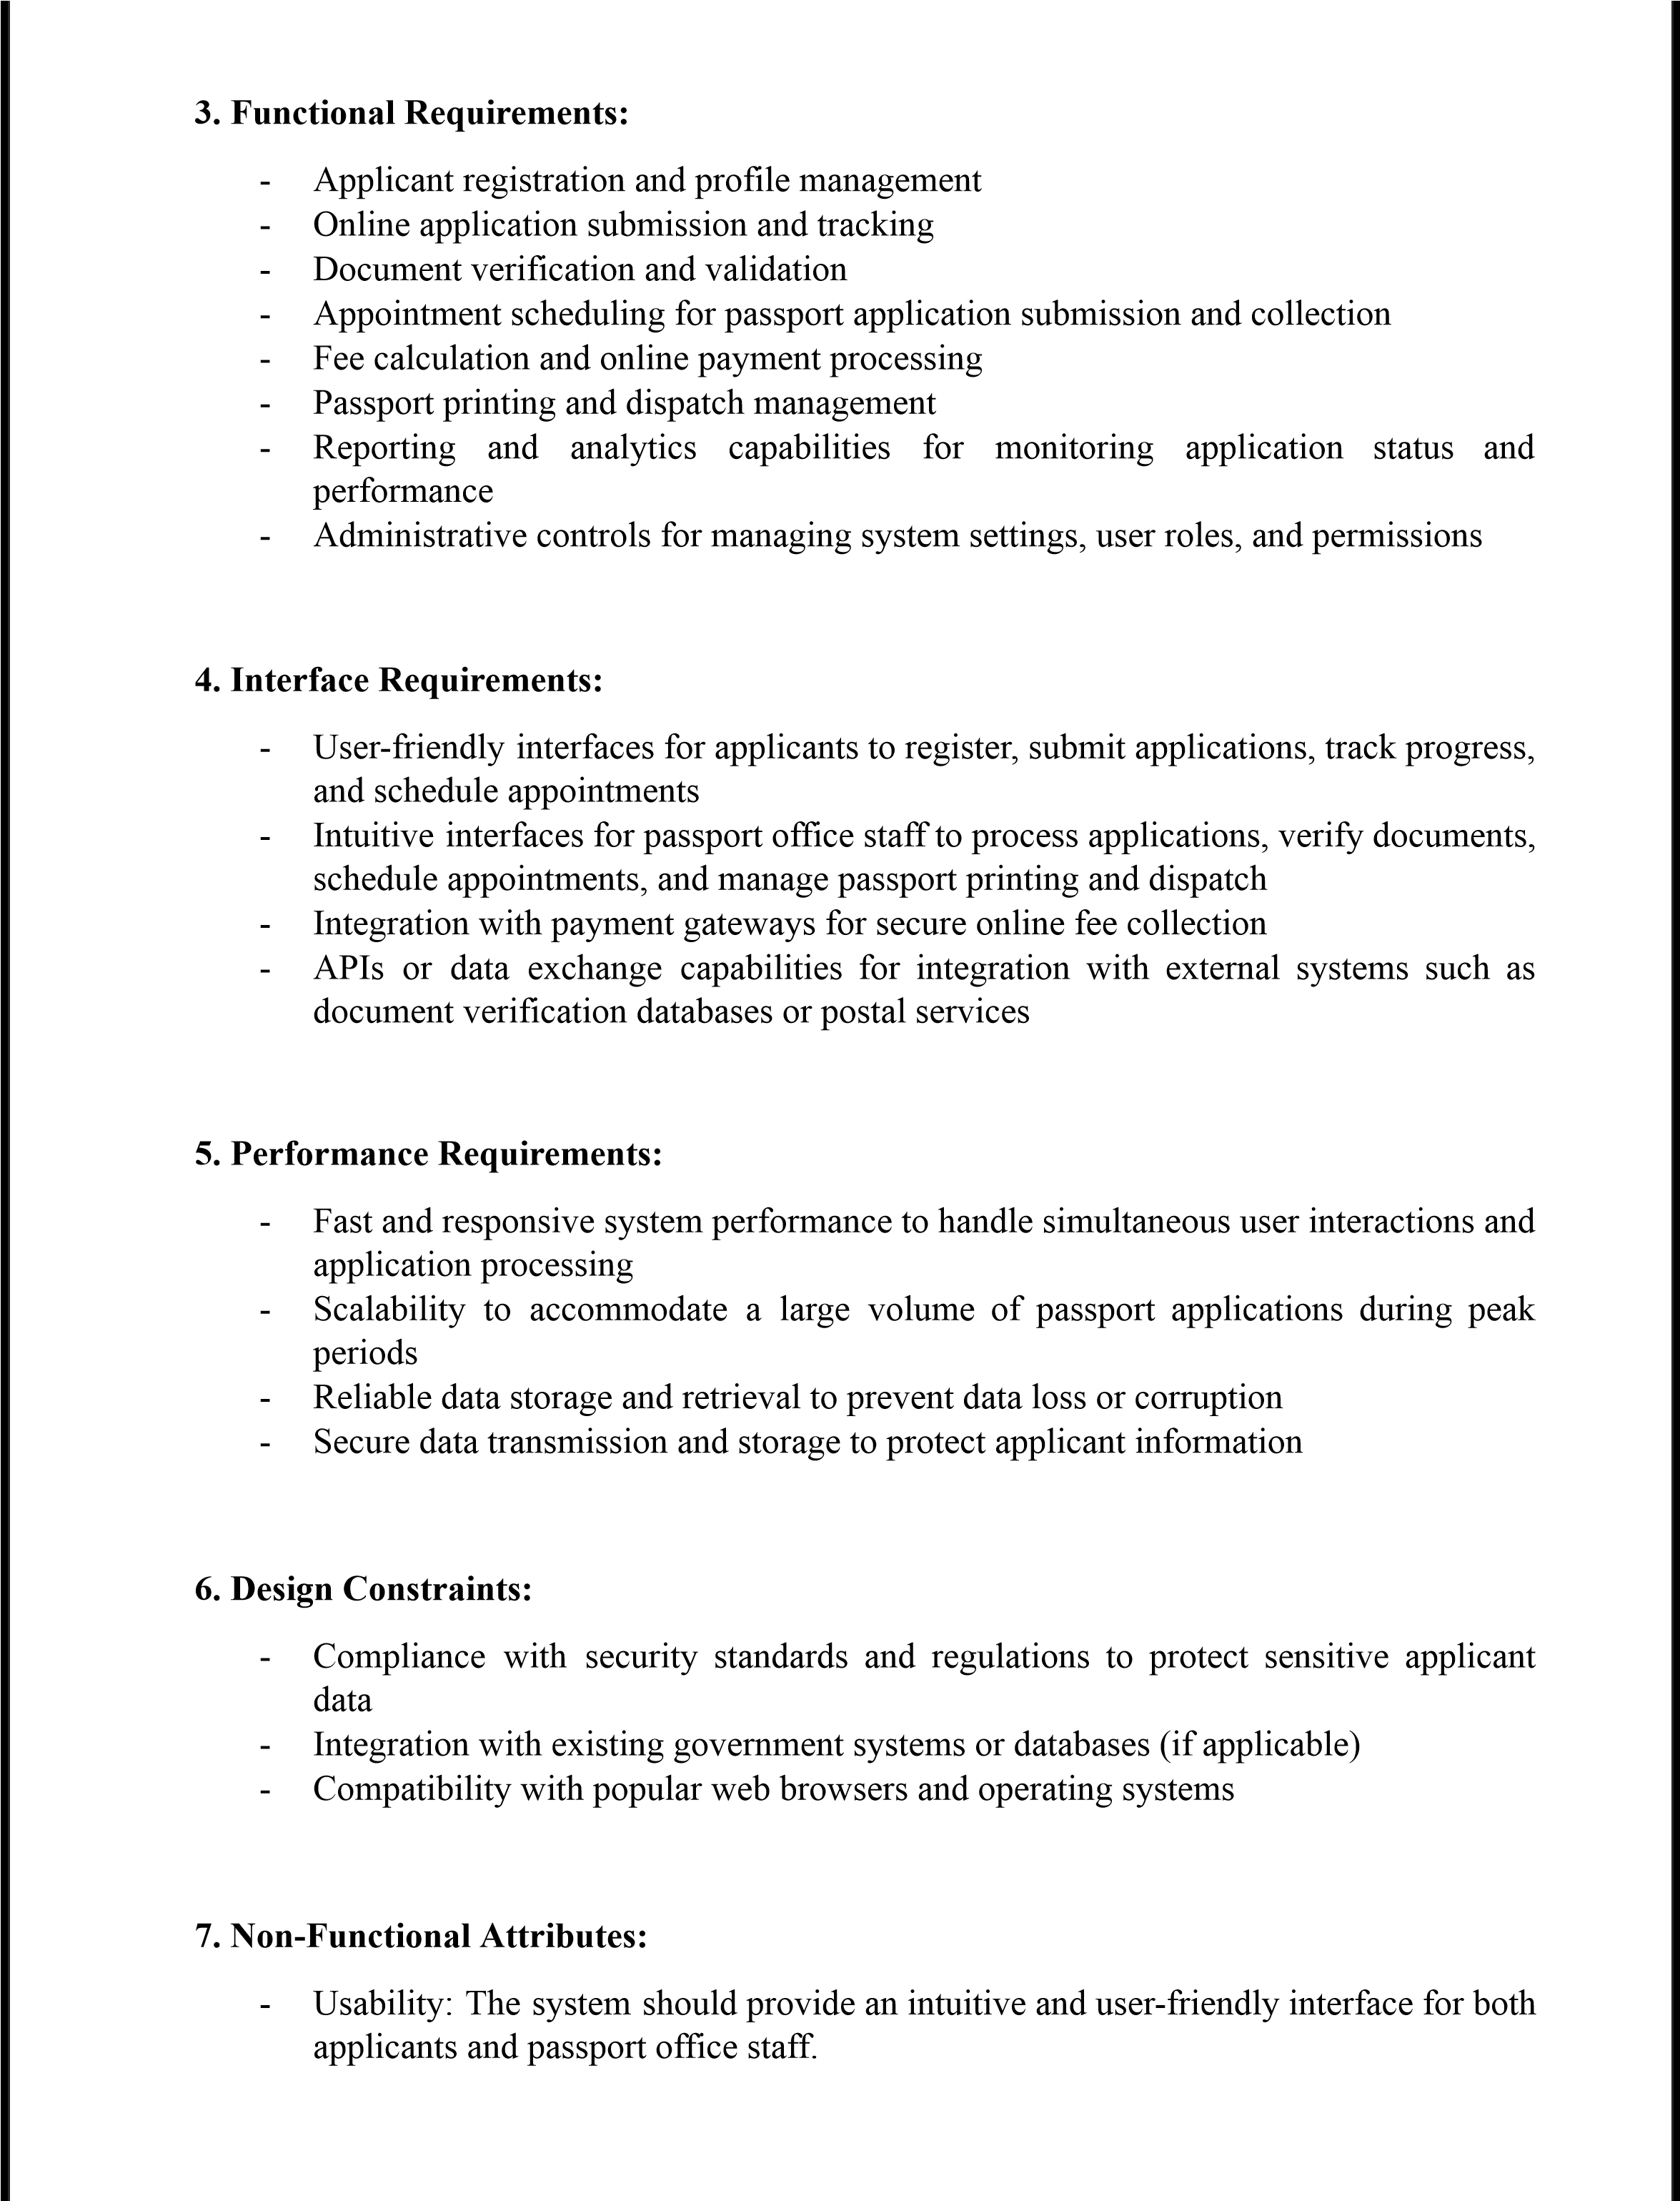



-

Reliability:

The

system

should

be

reliable

and

available

24

/

7

to

support

passport

issuance

operations

without

interruptions.

-

Security:

The

system

should

ensure

the

confidentiality

and

integrity

of

applicant

data

and

document

verification

processes.

-

Performance:

The

system

should

deliver

fast

response

times

and

handle

concurrent

user

requests

efficiently.

-

Maintainability:

The

system

should

be

easy

to

maintain

and

update

with

minimal

downtime.

Figure

5.1

Class

Diagram

of

Passport

Automation

System

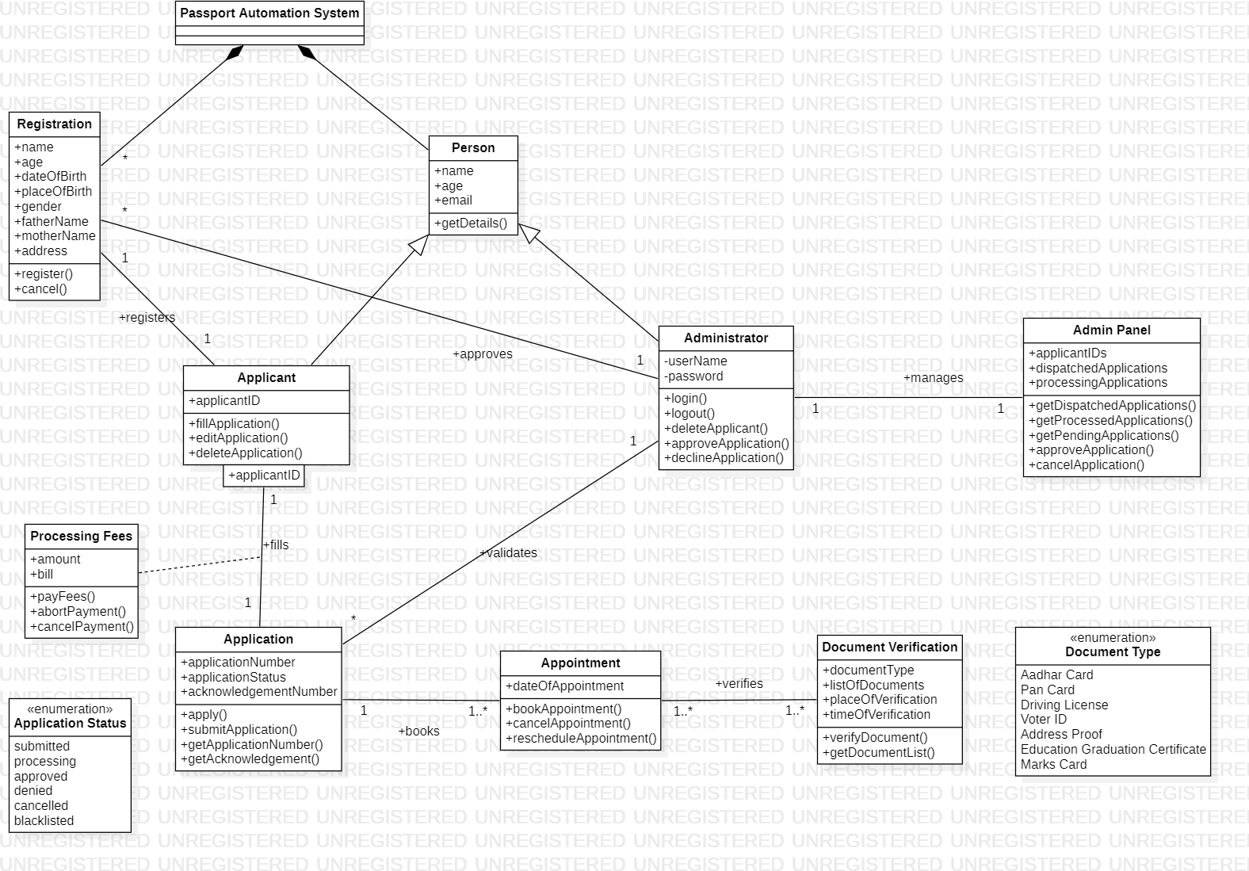

Figure

5.2

State

Diagram

of

Passport

Automation

System

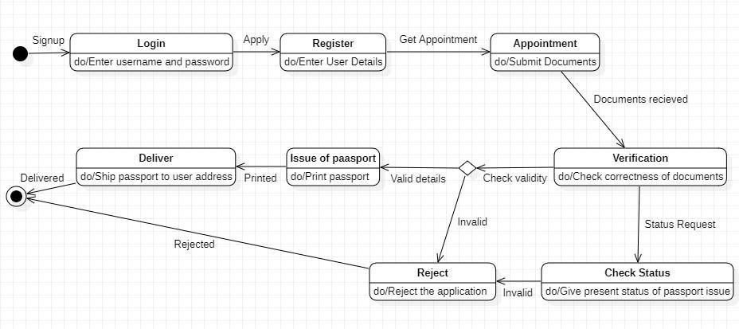

Figure

5.3

UseCase

Diagram

of

Passport

Automation

System

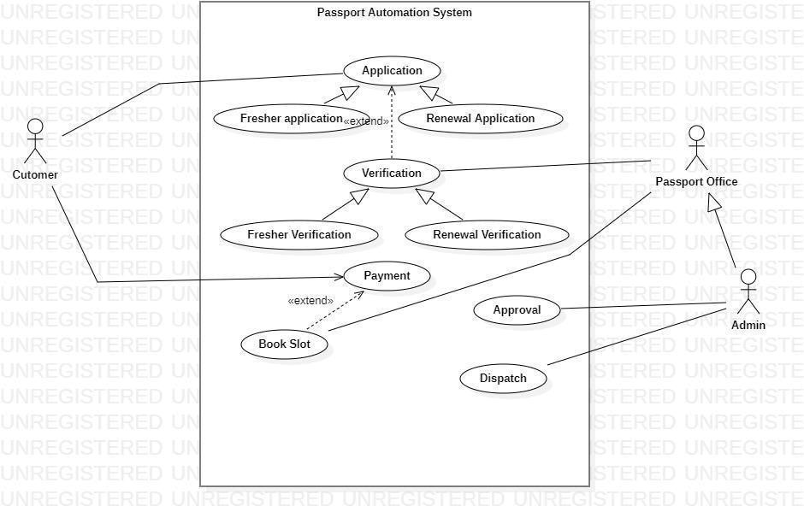

Figure

5.4

Sequence

Diagram

of

Passport

Automation

System

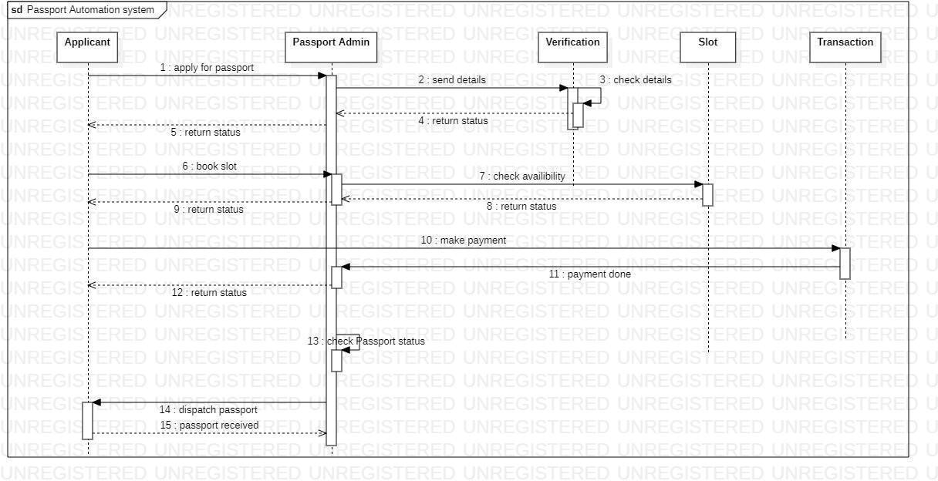

Figure

5.5

Activity

Diagram

of

Passport

Automation

System

